PGZ Decoding algorithm

1. Peterson-Gorenstein-Zierler algorithm basic

Compute the syndrome values by evaluating received polynomials and locators:



Solve the linear equations to get error locations:

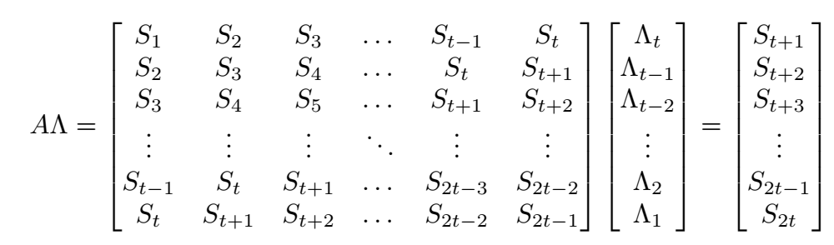

The matrix  is nonsingular(the determinant of  is not 0) if and only if there are exactly  errors.

Get error magnitudes:

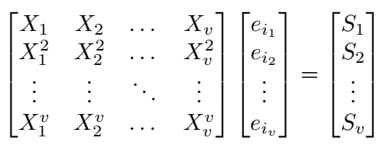

The procedure of this algorithm is summarize as below:

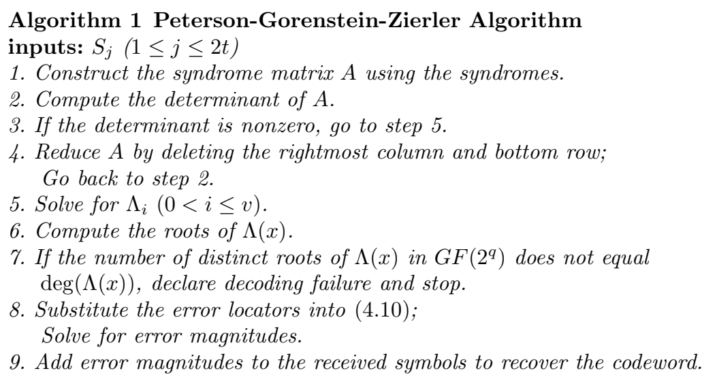

1. Decoder Architectures

The determinant and linear equations solving should be realized by combinational logic circuits. The mapping should be computed beforehand.

1. Complexity Analysis

See *Irene Giacomelli. "Improved Decoding Algorithms for Reed-Solomon Codes.", University of Pisa, 2012*：

